Welcome to Infinite Campus Food Service and Online Payments!
Through the Parent Portal, you can now conveniently log on to view individual account balances, sign up to receive low balance e-mail notifications, and view daily meal purchases in real time.
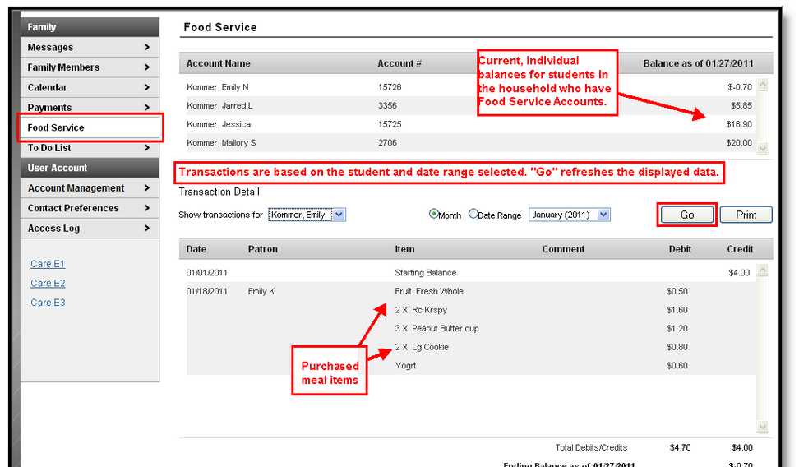
Visit https://landernv.infinitecampus.org/campus/portal/lander.jsp to begin viewing your child’s account.

You also have the convenience of using Campus Online Payments. This is a reliable and secure payment processing solution that allows you to submit food service payments 24/7 via the Portal.

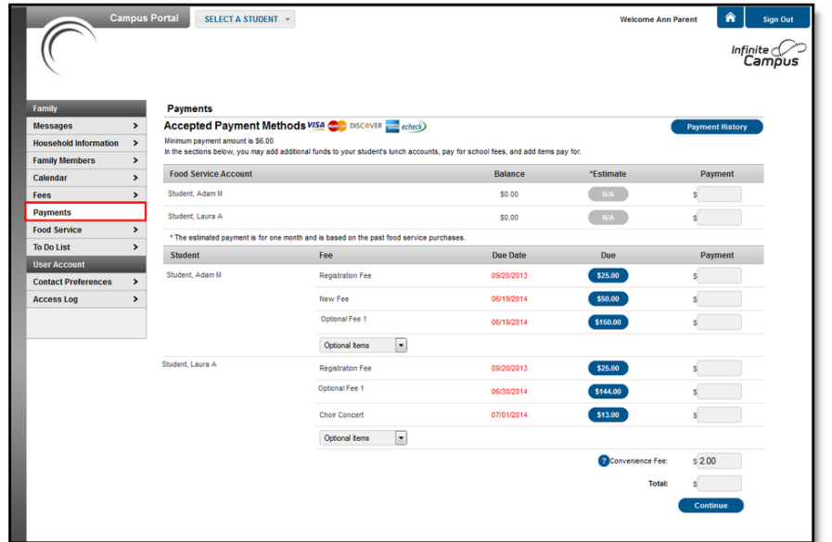
In addition, Campus Food Service works with the Campus Mobile Portal app and is accessible at your fingertips. With the app, you can view meal account balances for one or multiple children. The app can be downloaded for free from iTunes, Google Play or Amazon, depending on your device.

If you have any questions regarding Food Service, Online Payments or the Mobile Portal app, please contact Jillian Mills, LCSD Food Service Director, at 635-3332.

