Public Release for Free and Reduced Priced Meals School Year 2020-2021
The Lander County School District is pleased to announce our participation in the National School Lunch Program (NSLP) and the School Breakfast Program (SBP). If your household income is less than or equal to the following Federal Income Eligibility Guidelines (IEGs) below, your children are eligible for free or reduced priced meals.
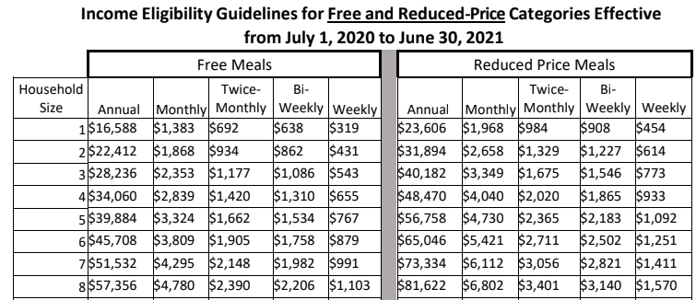
Application forms with instructions for completing them are being sent to all homes. To apply for free or reduced priced meals, households must fill out the application and return it to the school. Only one applications is needed for each household and applications may be completed and turned in at any time during the school year. Additional copies may be obtained from the Lander County School District Director of Food and Nutrition, 650 Altenburg Ave. Battle Mountain, NV. The information provided on the application will be used to determine eligibility and may be verified at any time during the school year by program officials.
For up to 30 operating days into the new school year, eligibility from the previous year will continue within the same school district. When this 30 operating day carry over period ends, unless the household is notified that their children are directly certified or the household submits an application that is approved, the children must pay full price for school meals. The school is not required to send a reminder notice of expired eligibility.
When known to the Lander County School District, households that have children that are categorically eligible through an assistance program, SNAP, TANF or FDPIR, or households that have children that are qualified as Other Source Categorically Eligible by being classified as; homeless, migrant, runaway, or enrolled in in an eligible head start or pre- K program, will be notified of the children’s eligibility for free meals. Applications do not have to be submitted for families in these circumstances. All children in the household qualify for free meal benefits and if they are not listed on the notification of free meal benefits, the household should contact the school district to have free meal benefits extended to them. If children are participating in the programs listed above and the family is not contacted by the school, the family should contact the school. Households that have been notified of their child’s eligibility must contact the school district to decline the free meal benefits.
Special Supplemental Nutrition Program for Women, Infants, and Children (WIC) participants may be eligible for free and reduced priced meals. Additionally, children of parents or guardians who become unemployed may be eligible for free and reduced price meals or free milk.
For school officials to determine eligibility and process applications for meal benefits, households must provide the following information on the application;
Income Based Applications
- Names of all household members
- Amount, source, and frequency of current income for each household member
- Signature of an adult household member
- Last 4 digits of the social security number of the household’s primary wage earner, or another adult household member’s social security number, or an indication that the household member does not have one.

Assistance Program Households: Households that are approved for the Supplemental Nutrition Assistance Program (SNAP), Temporary Assistance for Needy Families (TANF), or the Food Distribution Program on Indian Reservations (FDPIR), are automatically approved and need only provide the following information on their applications for free or reduced priced meal benefits;
- The names of all children for whom the application is made
- SNAP, TANF, FDPIR case number or identifier, for the children or any household member listed on the application
- The signature of the adult household member completing the application.

Other Source Categorically Eligibility: Families of children classified as homeless, migrant, or runaway, may submit an application with the following information;
- Names of the children for whom the application is made
- Indication of the child’s categorically eligibility status
- Signature of an adult household member

Foster Children: Foster children are automatically approved for free meal benefits. They may be included as a member of the foster family’s household, as this may help other children in the household qualify for benefits, if that family chooses to also apply for benefits for other children. If the foster family is ineligible for free or reduced benefits it does not prevent the foster child from receiving free meal benefits. A foster child only application should include the following;
- Name of the foster child
- Indication of the child’s foster care status
- Signature of an adult household member

Mixed Applications: These types of applications contain children who are other source categorically eligible, including foster children and the biological children on the household. These applications must include the following information;
- Names of all household members
- Amount and source of current income for each member and the frequency of income
- An indication of the program source of Other Source Categorical Eligibility Status
- Signature of an adult household member
- Last 4 digits of the social security number of the household’s primary wage earner, or another adult household member’s social security number, or an indication that the household member does not have one.

Parents or guardians dissatisfied with the ruling of the official may make a formal appeal either orally or in writing to Krissi Tucker, Hearing Official, 775-635-2886, for a hearing on the decision using the school districts appeals process.
In accordance with Federal civil rights law and U.S. Department of Agriculture (USDA) civil rights regulations and policies, the USDA, its Agencies, offices, and employees, and institutions participating in or administering USDA programs are prohibited from discriminating based on race, color, national origin, sex, disability, age, or reprisal or retaliation for prior civil rights activity in any program or activity conducted or funded by USDA.
Persons with disabilities who require alternative means of communication for program information (e.g. Braille, large print, audiotape, American Sign Language, etc.), should contact the Agency (State or local) where they applied for benefits. Individuals who are deaf, hard of hearing or have speech disabilities may contact USDA through the Federal Relay Service at (800) 877-8339. Additionally, program information may be made available in languages other than English.
To file a program complaint of discrimination, complete the USDA Program Discrimination Complaint Form, (AD-3027) found online at: http://www.ascr.usda.gov/complaint_filing_cust.html, and at any USDA office, or write a letter addressed to USDA and provide in the letter all of the information requested in the form. To request a copy of the complaint form, call (866) 632-9992. Submit your completed form or letter to USDA by:
(1) mail: U.S. Department of Agriculture
Office of the Assistant Secretary for Civil Rights
1400 Independence Avenue, SW
Washington, D.C. 20250-9410;

(2) fax: (202) 690-7442; or
(3) email: program.intake@usda.gov.
This institution is an equal opportunity provider

